Experiment-4

Use of appropriate command to determine your shell, available shell,using ‘who’ command and redirect to any text file,’more’ to view context in file.

* Use of the appropriate command to determine your large shell
* To find your current shell type following command -$ echo $ shell

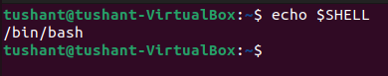

* To find all shells available in your system type this command-$ cat /etc/shells

To unify the above step use the following command $ cat/etc/passwd

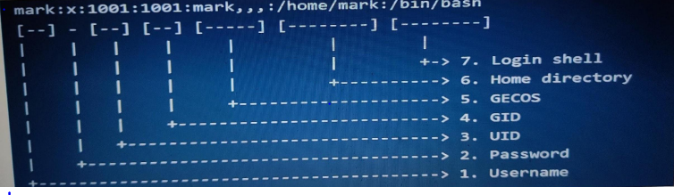

* Use the who command and direct the result a file called myfile.1.Use the more command see the context of my file1

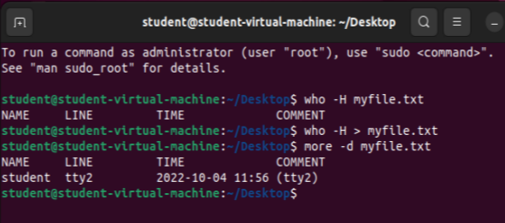

* Now use the data and who command in sequence , such that output of data will display on the screen and output of who will redirect to a file called myfile.2
* 